

**InnoNerds**

**BSSE- 1ST Semester**

**Lab report No 3**

**(Programming)**

Submitted to:

**Mr. Ali Akbar**

Submitted by:

**Khadija Ashraf**

**(24-SE-040)**

BS SOFTWARE ENGINEERING PROGRAM

DEPARTMENT OF COMPUTER SCIENCE HITEC UNIVERSITY, TAXILA

**Tasks:**

1. **Write a program that uses cout to display a simple table with 3 rows and 3 columns. Each cell should contain a number.**

**Answer:**

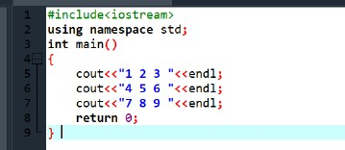

**Output:**

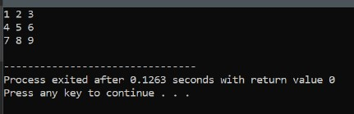

1. **Create a program that declares variables for your name, age, and city. Then, display this information using cout.**

**Answer:**

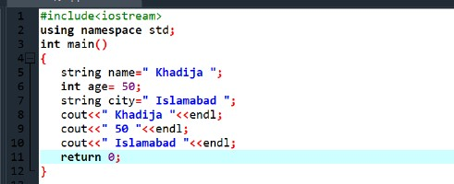

**Output:**

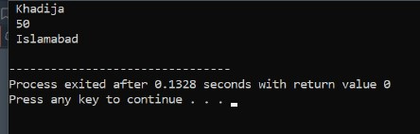

1. **Write a program that declares two variables for the length and width of a rectangle. Calculate and display the area of the rectangle using the formula area = length* width.**

**Answer:**

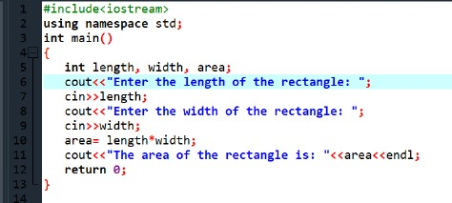

**Output:**

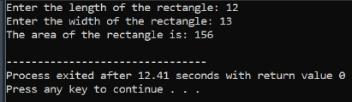

1. **Write a program that asks the user to input a number and uses if-else conditions to check if the number is positive, negative, or zero.**

**Answer:**

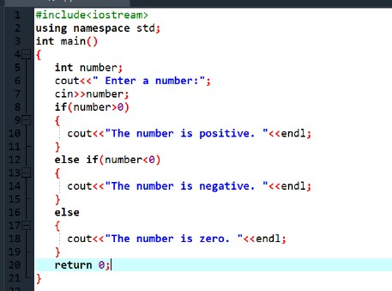

**Output:**

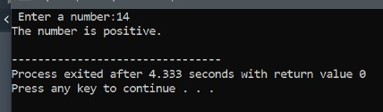

1. **Write a program that asks the user to enter two numbers and compares them using**

**if-else. Display which number is greater or if they are equal.**

**Answer:**

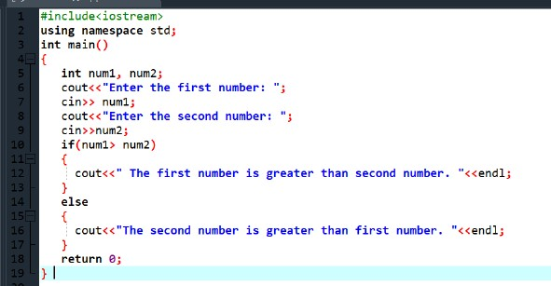

**Output:**

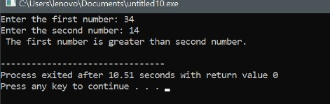

1. **Write a program that stores your favorite quote in a string variable and prints it using cout.**

**Answer:**

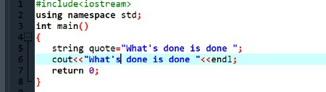

**Output:**

